TWIN TOWNS OF PŁOŃSK:
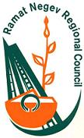
Ramat-Negev (ISRAEL)
www.rng.org.il/en/
The population: 6 thousands of inhabitants
The ddistrict of Ramat Negev is located the southern part of Israel. It is the largest area in Israel of local government in that region. Areas in the middle of the Negev desert fall under the jurisdiction of the local government.
David Ben Gurion in the last 20 years of his life lived in that area – he was the first Prime Minister of Israel, born in Płońsk. This distinguished individual was the reason for establishing relations between Płońsk and Ramat Negev which resulted in the signing of a cooperation agreement in 1997.
In the framework of this agreement are organized meetings between youths from both countries and cultivating history and traditions. Every year a group of students from Ramat Negev come to Płońsk, where they meet up with their peers. It has become a tradition that each new Israeli ambassador in Poland visits Płońsk to meet with the inhabitants. In cooperation with Ramat Negev Płońsk is featured as a place to visit by large tourist groups traveling from Israel and visiting Poland.

Crépy-en-Valois (FRANCE)
www.crepyenvalois.fr
The population: 15 thousand inhabitants
Crépy-en-Valois is located in the French region of Picardy, in the department of Oise, about 60 km from Paris in the north-east. The rich history and splendor of this town presents architecture from the fourteenth to the sixteenth century that we can admire at every step. The Old Walon Castle invites all who want to know the history of the town and enter the world of traditional archery and enjoy the beauty of religious art.
In Crépy-en-Valois there is a large concentration of people of Polish descent, hence the idea to establish a cooperation agreement with Płońsk. This agreement between Płońsk and Crépy en Valois was signed in 2002. In the framework of this agreement are organized annual meetings between youth and exchanges. There are also regular meetings of large groups of residents from both towns involving mutual participation in cultural events, sports and realization of joint projects.

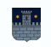
Čakovec (CROATIA)
www.cakovec.hr
The population: 16 thousand inhabitants
Čakovec is located in the district of Medimursk in the north of Croatia between the river Mura and Drava. It is the second largest town located in this region of the country. It is also the cultural and economic center of the region. Renowned for its hunting grounds, vineyards and excellent crops, and the proximity of the health resort village it is a very attractive holiday destination. Croatian Čakovec is a twin town partnered with Płońsk since 2002. Cooperation between these two towns is on the basis of cultural and sporting events.

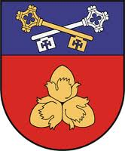
Soleczniki (LITHUANIA)
www.salcininkai.lt
The population: 40 thousand inhabitants
The Region of Soleczniki is located in the south-eastern part of Lithuania in the Vilnius district. The area of this region is 1,491.4 km sq.This area has the largest Polish community in Lithuania, 80% - are Poles. Soleczniki region is an area of great beauty, magnificent landscapes, interesting monuments, natural oddities. In the region there are et lot of Churches, palaces, prehistoric stones and ancient burial mounds, unique architecture specific to old villages. The statistics demonstrate the existence of 280 different cultural monuments, among which include 13 churches, two orthodox churches, chapels, buildings of ancient palaces and manors. Soleczniki it is the administrative center of the region situate 44 km from Vilnius – the capital of Lithuania. The beginnings of Soleczniki go back to the XIII century. Adam Mickiewicz one of the most famous polish novelists frequented this town. In 2002, the agreement between Płońsk and Soleczniki Region was signed. This co-operation entails mainly the aspects relating to cultural, sports, and youth exchange.


Bahchisaray ( UKRAINE)
www.bahchisaray.in.ua
The population: 34 thousand inhabitants

Bahchisaray is a town in the Ukraine, located in the Crimean Mountains, along the route from Simferopol to Sevastopol.The former capital of the Crimean Khanate. Through the town flows the river Czuruksu that separates the left bank of the old historic part of the town from the new one on the right bank of the river. Bahchisaray was founded at the beginning of the fifteenth century on the terrain of the former Tatar settlement Eski-Yurt. Bahchisaray culturally is still the capital of the Crimean Tatars. Located there is a one of the most valuable monuments of the peninsula – the Khans palace complex.
In this area there are other important monuments such as: the Uspensky monastery sculpted into the very rock of a mountain and adjacent village is also located in the mountain. Adam Mickiewicz, one of the most famous Polish poets devoted to the city a number of sonnets: "Crimean Sonnets": "Bahchisaray", "Bahchisaray at night", " The Tomb of Potocki", " The Graves of Harem".
The agreement for cooperation between Płońsk and Bahchisaray was signed in 2004. The cooperation entails cultural exchange and sharing experiences relating to administrative work at the local-government level and democracy.
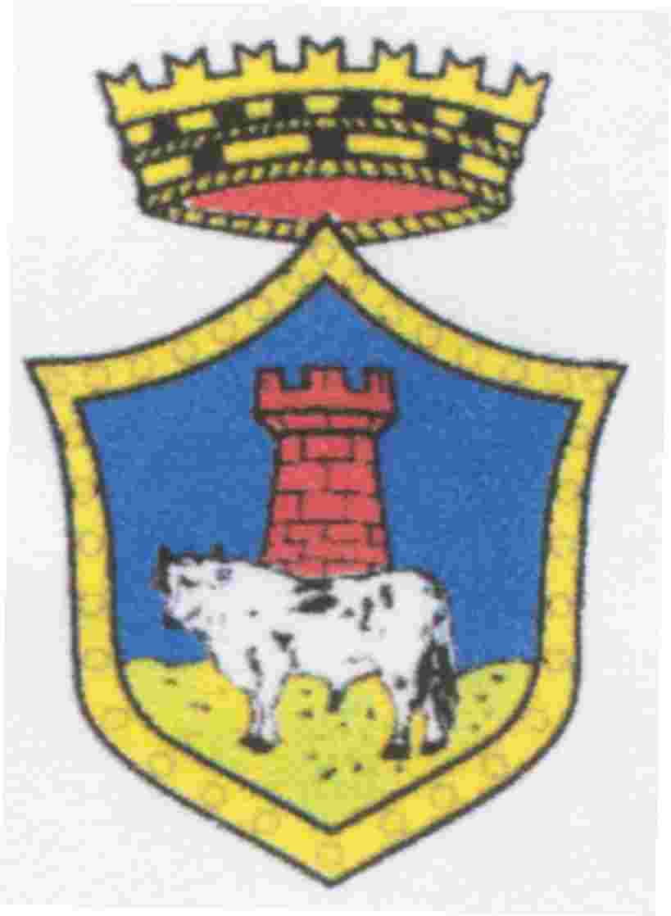
Notaresco (ITALY)
www.comune.notaresco.te.it
The population: 7 thousand inhabitants
The picturesque town of Notaresco is located in the region of Abruzzo which is part of the province of Teramo on the shores of the Adriatic.
Mountains of the Italian region of Abruzzo were a place often visited by Pope John Paul II. The first mention of the city comes from the beginning of the last millennium. The architecture of Notaresco is typically medieval.
The Italian Town of Notaresco is partnered with Płońsk since 2008. The cooperation entails primarily cultural and mutual participation in different groups and artistic events.

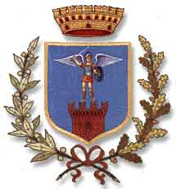
Mosciano Sant'Angelo (ITALY)

www.comune.mosciano.te.it

The population: 8 thousand inhabitants

Mosciano is a medieval town located in the picturesque region of Abruzzo in the Italian province of Teramo. The historic character of this town is highlighted by the numerous monuments that are located there. At present Mosciano is an important center for agriculture (viticulture and olive oil production) as well as commerce and trade in thats region.
Mosciano cooperates with it’s twin partner town of Plonsk since 2010. The cooperation involves primarily cultural events, in particular cooperation between the Youth Brass Band Orchestras and folk music ensembles.

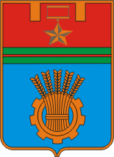
Volgograd (RUSSIA)
www.volgadmin.ru
The population: 1 millon inhabitants
Volgograd is a district city in Russia, on the lower Volga river, it was formerly called Tsaritsyn and Stalingrad. During World War II, the city saw fierce fighting, it is the place where took place the Battle of Stalingrad, which ended with the defeat of the German army. It also almost completely destroyed the city. Honoring and celebrating the memory of these tragic and heroic events are very important policies of the city administration.
At present Volgograd is a major railway junction with busy airport. It is also the center for the machine industry, transport equipment (tractors), metallurgical, chemical (mainly petrochemicals), timber and construction materials. In Volgograd are 7 high schools (including one university).
The cooperation between Płońsk and Volgograd began through the International Association of Peace Messengers City. The official partnership agreement was signed in 2008 and entails activities relating to cultural, sporting and youth exchanges.

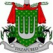
Tiszafüred (HUNGARY)
www.tiszafured.hu
The population:15 thousand inhabitants
Tiszafüred is located in central Hungary, on Lake Tisza (Tisza). It is a tourist destination, which features: beaches, unspoiled nature and thermal complex. The water in the thermal pools has beneficial effects for a variety of rheumatic and muscular aliments. Active leisure in Tiszafüred also include: horseback riding, kayaking and cycling. Tiszafüred is also an important center of Hungarian folk art and crafts.
The official signing of the partnership agreement between Płońsk and Tiszafüred took place in 2013. The cooperation started involves all areas of culture and education.
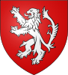
Antoing (BELGIA)
www.antoing.net
Population: 7,5 thousand inhabitants
The town of Antoing is located in the French speaking province of Hainaut, in the south of Belgium, 30 km from the border with France. Near the town passes the TGV lines linking Paris, London and Brussels. This region is called „Pays Blanc” - White Country due to the large number of quarries. The town is dominated by a medieval castle, which in the nineteenth century it was transformed into a beautiful neo-Gothic residence.
Płońsk signed a partnership agreement with Antoing in 2013. Contacts between the towns had been established through the French city of Crepy en Valois, which has been working with Antoing for over 50 years. The cooperation between Płońsk and Antoing began with reciprocal visits by representatives of both town administrations, during which they shared their experiences in the field of municipal management (garbage, sewerage, waterwarks). The towns of: Antoing, Płońsk, Crepy en Valois and Zell Mosel jointly carried out the project of writing a book based on Carole Bonnet’s original idea (a native Belgian writer). This adventure book was called - "Mission Europe". It was written by primary school children, illustrating their town and their home as seen through their eyes. The book was published in three languages: French, German and Polish.

